Dynamic Support Register referral form

The Dynamic Support Register list is a register of children, young people and adults with a Learning Disability and Autistic people.
People on the Dynamic Support register are at risk of going into hospital if they do not get the right care and treatment in the Community.
The Dynamic Support Register is used to make sure that the right checks are carried out by health and care teams.

 | Your name:
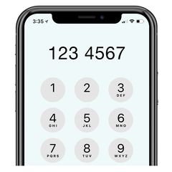 | Your phone number
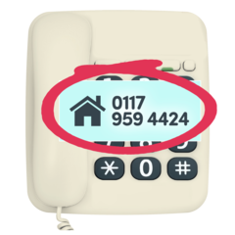 | Name and phone number of person filling in the form for you:
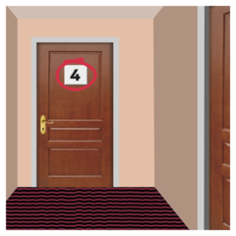 | What is your address?
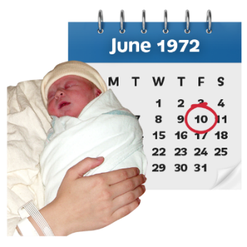 | What is your date of birth?
 | What is your gender identity?
 | What are you preferred pronouns?
 | What is your NHS number?
 | Do you have keyworker?  What is their name?
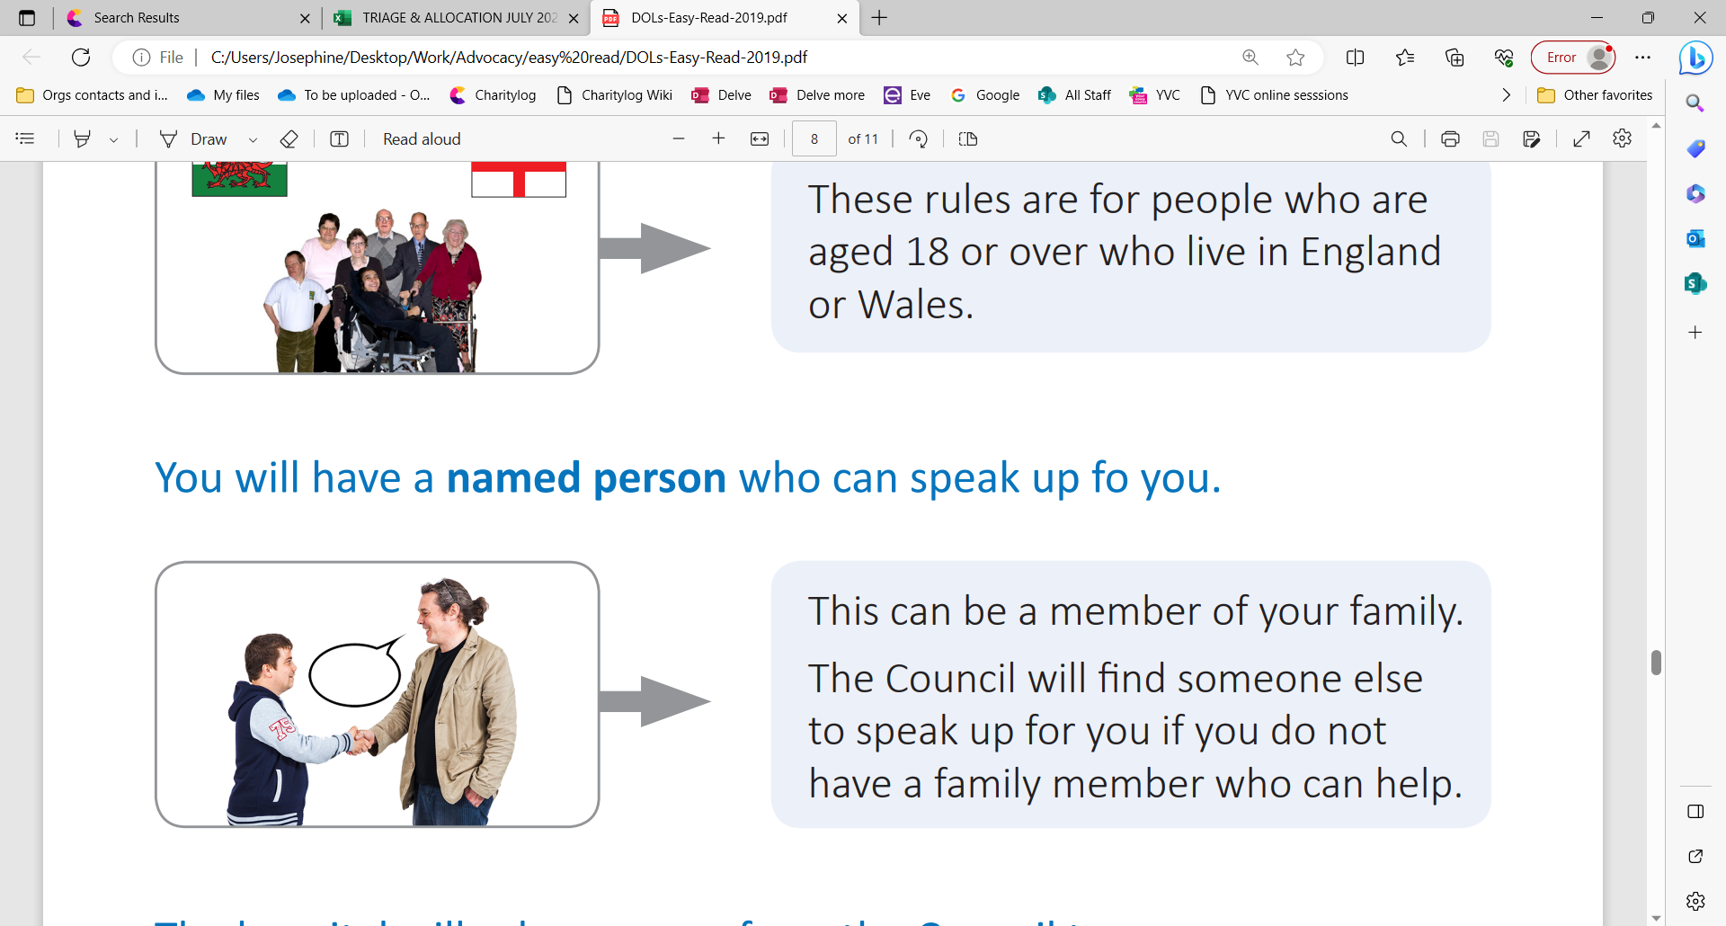 | Do you have an advocate?  What is their name?
 | Do you use words, makaton, sign language, pictures, or gestures to communicate?  Please write in the box below
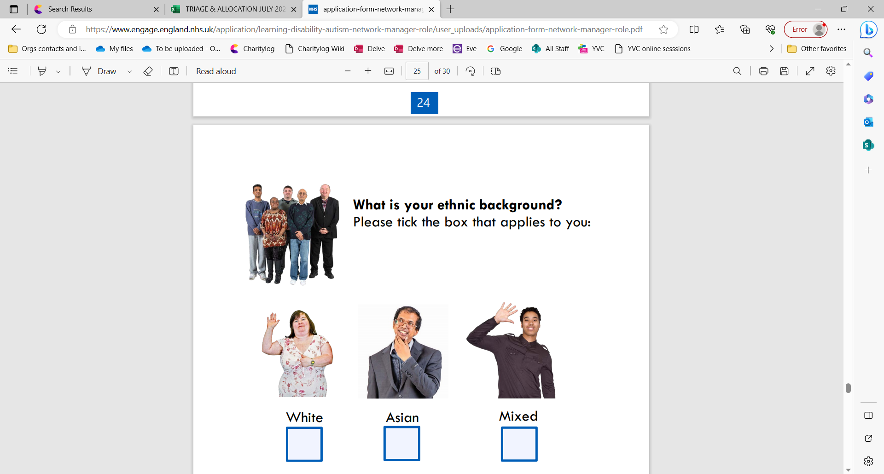 | What is your ethnic background: |  |  | 
 | White – any White background
 | Asian or Multiple Ethnic Groups
 | Mixed or Multiple Ethnic Groups
 | Asian or Asian British
 | Prefer not to say
 | Not Specified / Unknown
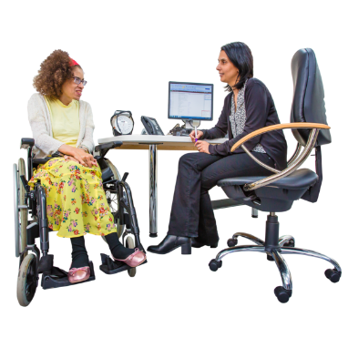 | Which doctors surgery do you go to?
Who can we speak to about this form? | Name:  Their phone number/Mobile phone number:
 | This information will be stored securely and will only be used to help you with the issues you are facing and to help to improve the care you are getting. It may be shared if you are:  - in danger  - at risk of being harmed  Someone else is at risked of being harmed.
   | It may be shared with people like your social worker, South Tyneside Council, and other organisations in order to help you.
 | If you have any questions or concerns about the Register please speak to [Referrer].  If you have any further questions, please feel free to get in touch.  Simon Robinson and Rachel Wharton – Complex Case Facilitators  Telephone: 0191 640 0165
Please tick yes or no to let us know you are happy for us to use and share your information in the way described. | Yes
 |  No

Signature

